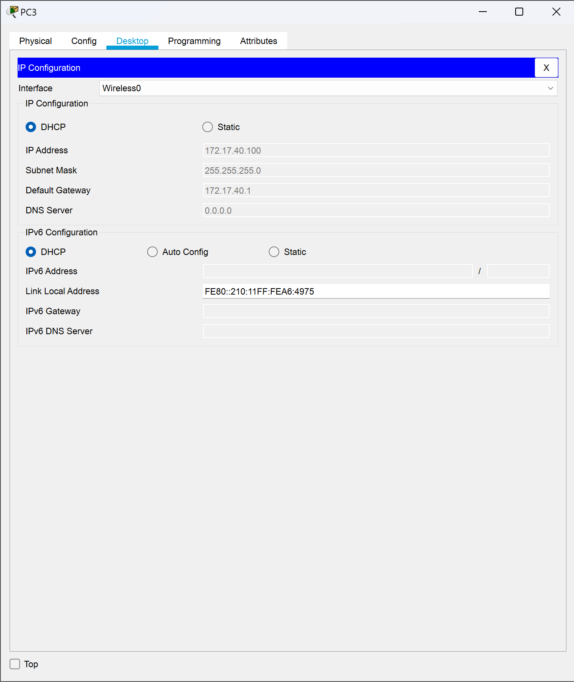

TASK 2:

LỆNH SHOW RUN:

% Invalid input detected at '^' marker.

R1#show run

Building configuration...

Current configuration : 1316 bytes

!

version 15.1

no service timestamps log datetime msec

no service timestamps debug datetime msec

service password-encryption

!

hostname R1

!

!

!

enable secret 5 $1$mERr$9cTjUIEqNGurQiFU.ZeCi1

!

!

!

!

!

!

ip cef

no ipv6 cef

!

!

R1#show run

Building configuration...

Current configuration : 1316 bytes

!

version 15.1

no service timestamps log datetime msec

no service timestamps debug datetime msec

service password-encryption

!

hostname R1

!

!

!

enable secret 5 $1$mERr$9cTjUIEqNGurQiFU.ZeCi1

!

!

!

!

!

!

ip cef

no ipv6 cef

!

!

!

!

license udi pid CISCO1941/K9 sn FTX15240P9D

!

!

!

!

!

!

!

!

!

!

!

spanning-tree mode pvst

!

!

!

!

!

!

interface GigabitEthernet0/0

ip address 192.168.10.1 255.255.255.0

duplex auto

speed auto

!

interface GigabitEthernet0/1

ip address 192.168.11.1 255.255.255.0

duplex auto

speed auto

!

interface Serial0/0/0

ip address 209.165.200.225 255.255.255.252

clock rate 64000

!

interface Serial0/0/1

no ip address

clock rate 2000000

shutdown

!

interface FastEthernet0/1/0

switchport mode access

switchport nonegotiate

shutdown

!

interface FastEthernet0/1/1

switchport mode access

switchport nonegotiate

shutdown

!

interface FastEthernet0/1/2

switchport mode access

switchport nonegotiate

shutdown

!

interface FastEthernet0/1/3

switchport mode access

switchport nonegotiate

shutdown

!

interface Vlan1

no ip address

shutdown

!

router eigrp 1

network 192.168.10.0

network 192.168.11.0

network 209.165.200.0

auto-summary

!

ip classless

!

ip flow-export version 9

!

!

!

!

!

!

!

!

line con 0

password 7 0822455D0A16

login

!

line aux 0

!

line vty 0 4

login

!

!

!

End

LỆNH SHOW IP INTERFACE BRIEF:

LỆNH SHOW IP ROUTE:

TASK 3:

Cho mô hình trên và địa chỉ 192.168.100.0/24, hãy xác định:

_Có 5 mạng con.

|  |  |  |  |  |
| --- | --- | --- | --- | --- |
| STT | Địa chỉ mạng | Địa chỉ đầu | Địa chỉ cuối | Địa chỉ broadcast |
| 0 | 192.168.100.0 | 192.168.100.1 | 192.168.100.30 | 192.168.100.31 |
| 1 | 192.168.100.32 | 192.168.100.33 | 192.168.100.62 | 192.168.100.63 |
| 2 | 192.168.100.64 | 192.168.100.65 | 192.168.100.94 | 192.168.100.95 |
| 3 | 192.168.100.96 | 192.168.100.97 | 192.168.100.126 | 192.168.100.127 |
| 4 | 192.168.100.128 | 192.168.100.129 | 192.168.100.158 | 192.168.100.159 |
| 5 | 192.168.100.160 | 192.168.100.161 | 192.168.100.190 | 192.168.100.191 |
| 6 | 192.168.100.192 | 192.168.100.193 | 192.168.100.222 | 192.168.100.223 |
| 7 | 192.168.100.224 | 192.168.100.225 | 192.168.100.254 | 192.168.100.255 |

Gán Subnet 0 cho mạng LAN kết nối đến GigabitEthernet 0/0 interface của R1

Gán Subnet 1 cho mạng LAN kết nối đến GigabitEthernet 0/1 interface của R1

Gán Subnet 4 cho kết nối giữa R1 to R2

Cho địa chỉ 192.168.100.0/24

Địa chỉ sử dụng được là 192.168.100.[1-254]

Địa chỉ toàn mạng là 192.168.100.[0-255]

Cần tìm ít nhất 4 mạng con mà mỗi mạng con có 25 máy

Mỗi mạng con cần ít nhất là 25 máy

5 bit: HOST ID

Mượn 3 bit để chia mạng con, vì vậy ta có 23 = 8 mạng con và 25 − 2 = 30 máy sử dụng được trên 1 mạng con

Bảng các địa chỉ IP:

|  |  |  |  |  |
| --- | --- | --- | --- | --- |
| Device | Interface | IP Address | Subnet Mask | Default Gateway |
| R1 | G0/0 | 192.168.100.1 | 255.255.255.224 | N/A |
| G0/1 | 192.168.100.33 | 255.255.255.224 | N/A |
| S0/0/0 | 192.168.100.129 | 255.255.255.224 | N/A |
| R2 | G0/0 | 192.168.100.65 | 255.255.255.224 | N/A |
| G0/1 | 192.168.100.97 | 255.255.255.224 | N/A |
| S0/0/0 | 192.168.100.158 | 255.255.255.224 | N/A |
| S1 | VLAN1 | 192.168.100.2 | 255.255.255.224 | 192.168.100.1 |
| S2 | VLAN1 | 192.168.100.34 | 255.255.255.224 | 192.168.100.33 |
| S3 | VLAN1 | 192.168.100.66 | 255.255.255.224 | 192.168.100.65 |
| S4 | VLAN1 | 192.168.100.98 | 255.255.255.224 | 192.168.100.97 |
| PC1 | NIC | 192.168.100.4 | 255.255.255.224 | 192.168.100.1 |
| PC2 | NIC | 192.168.100.62 | 255.255.255.224 | 192.168.100.33 |
| PC3 | NIC | 192.168.100.94 | 255.255.255.224 | 192.168.100.65 |
| PC4 | NIC | 192.168.100.126 | 255.255.255.224 | 192.168.100.97 |

